BIT4107 Project Progress Documentation
Week 1: Environment Setup
I successfully configured the Flutter development environment and created the foundational "Hello World" application.

Fig1:hello world

Week 2: mobile environment development
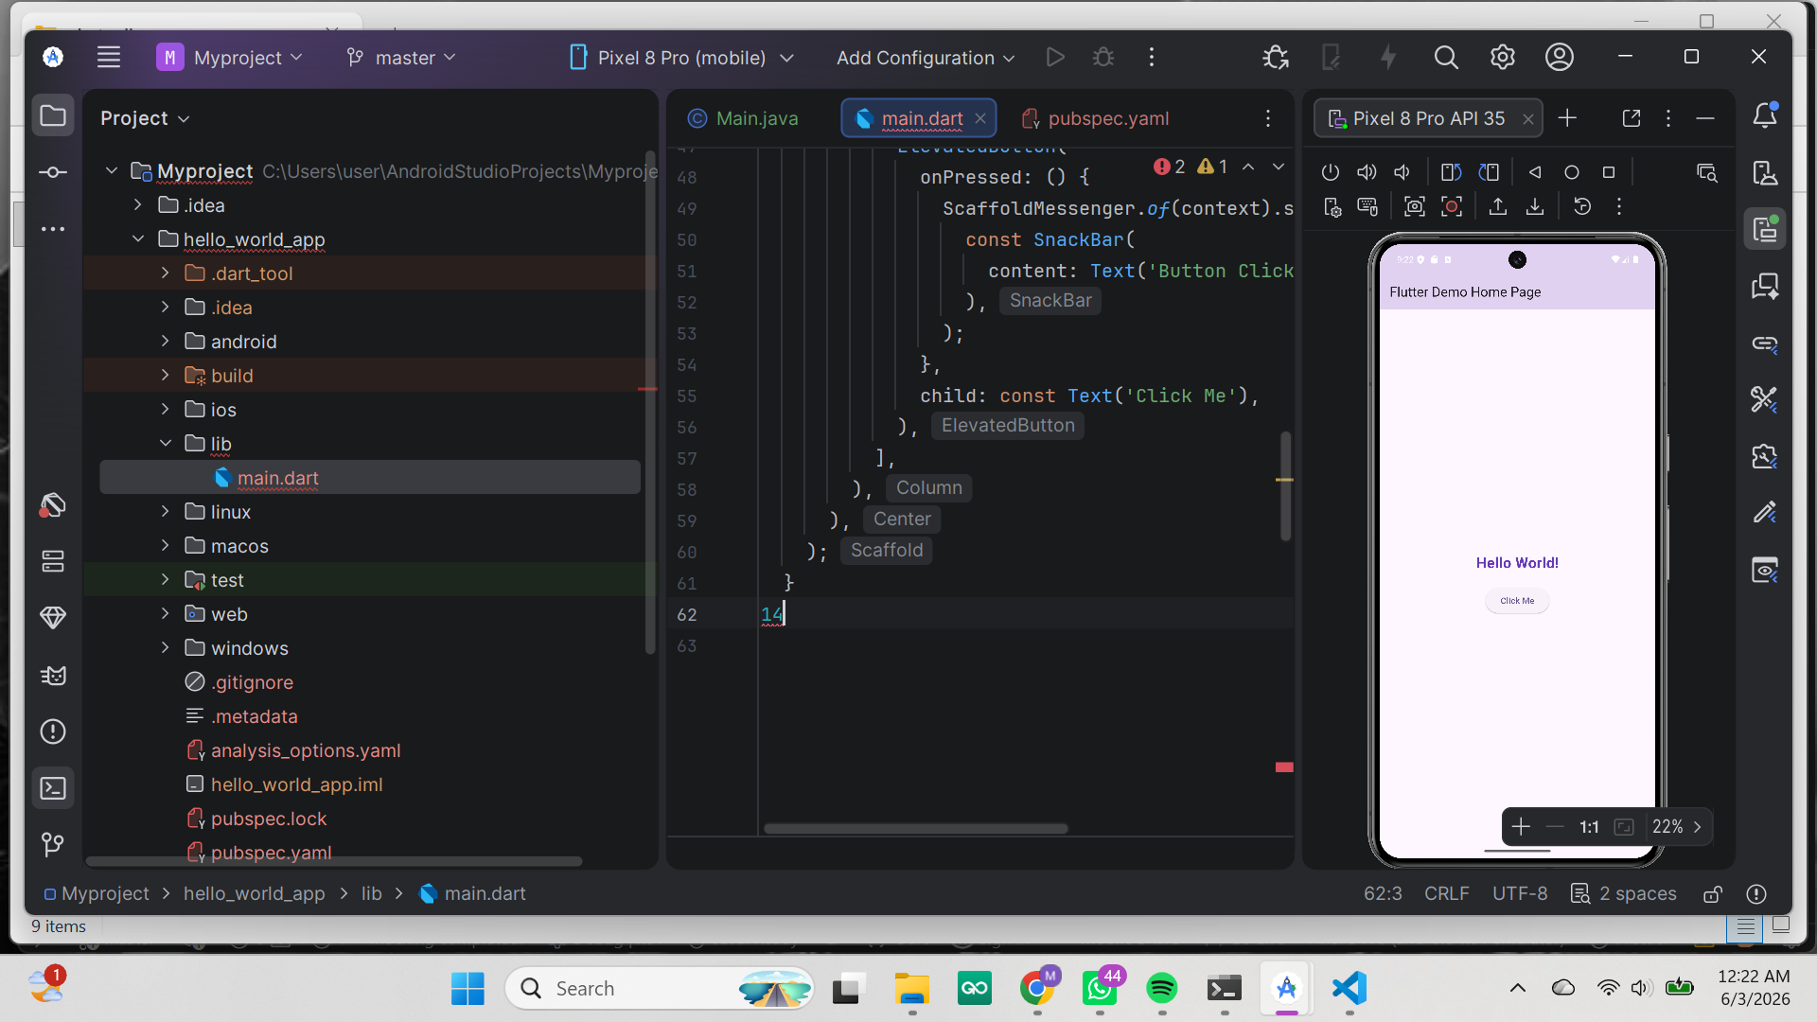
Fig 2: hello world

Week 3: user inetface design
I designed and implemented the user authentication interface and the main dashboard navigation screens.

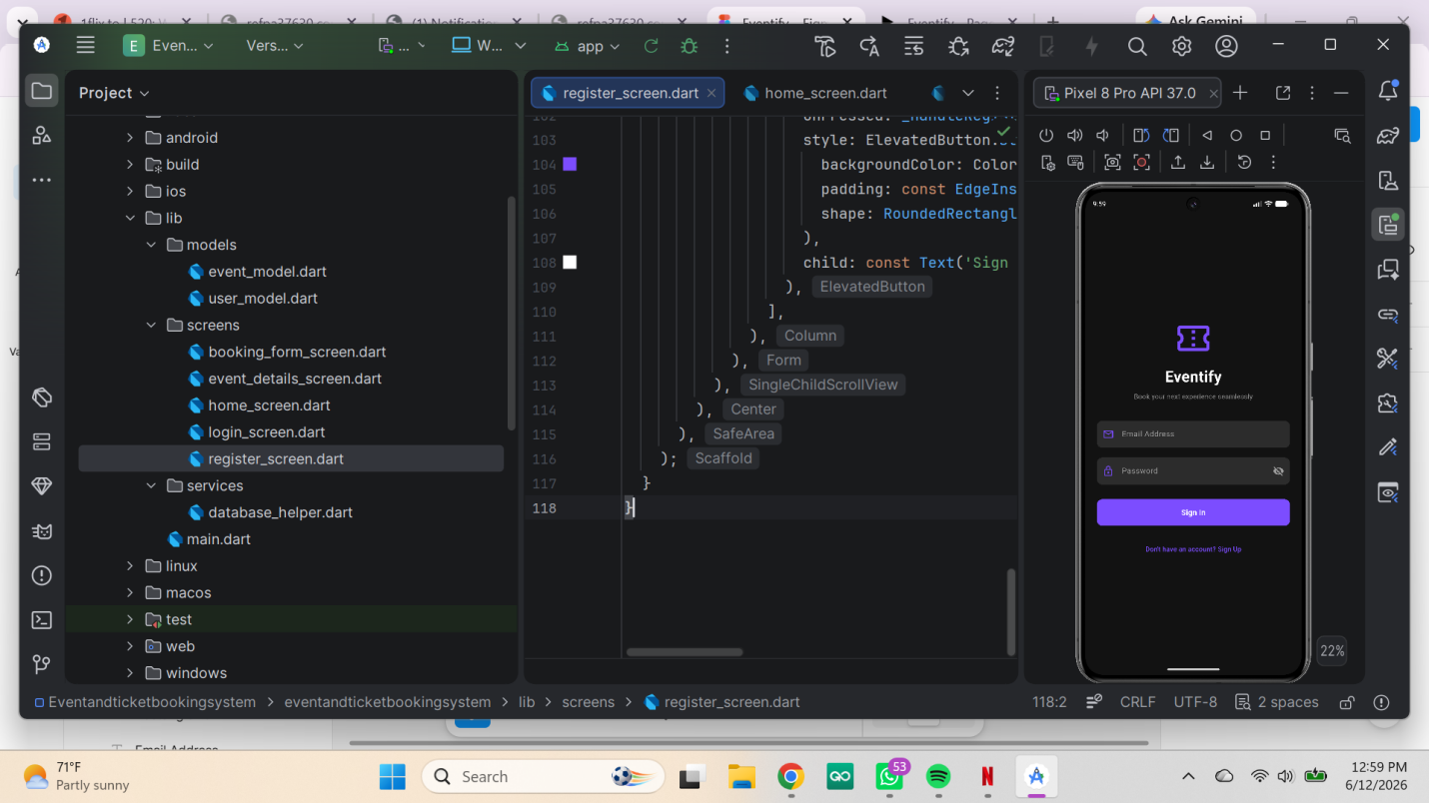
Fig2:login screen

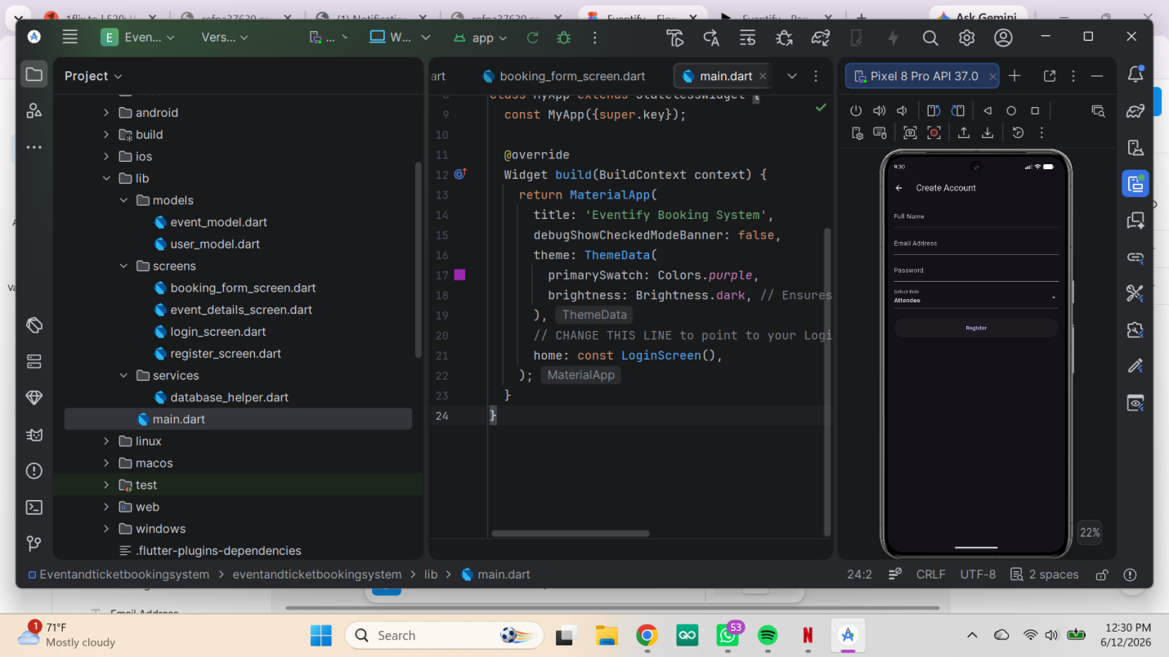
Fig3: registration screen

Week 4: Event handling and user interaction
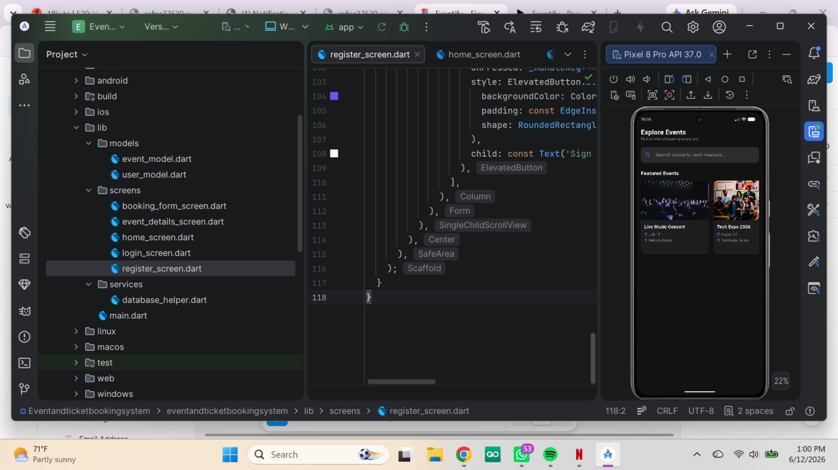
Fig 4: home_screen

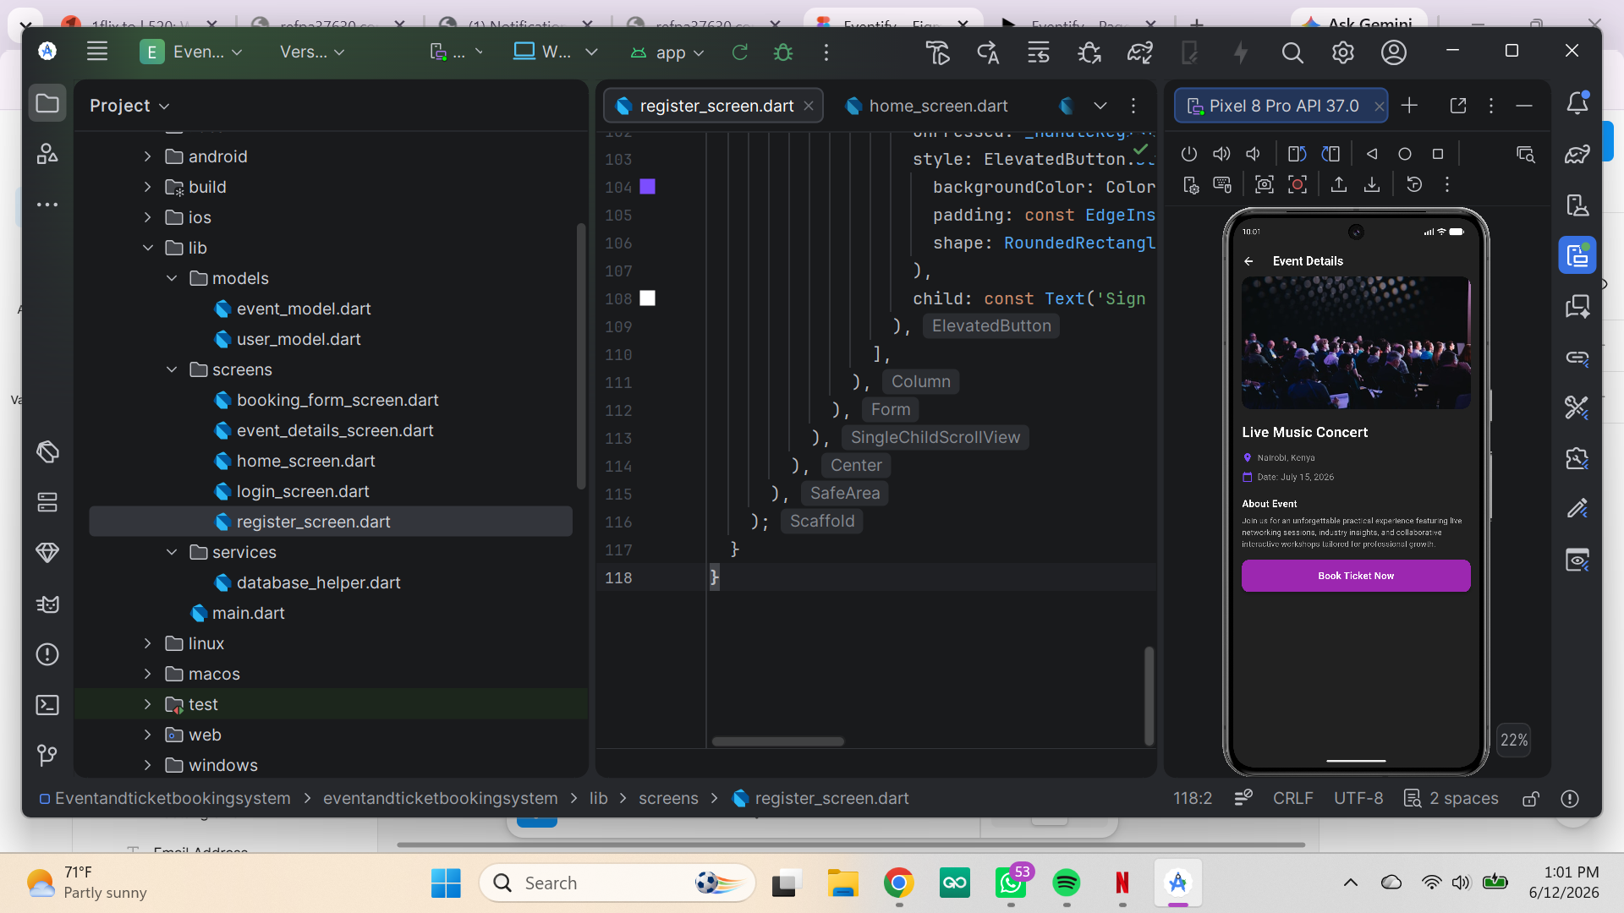

Fig 4: Event details screen

Fig 5: booking form

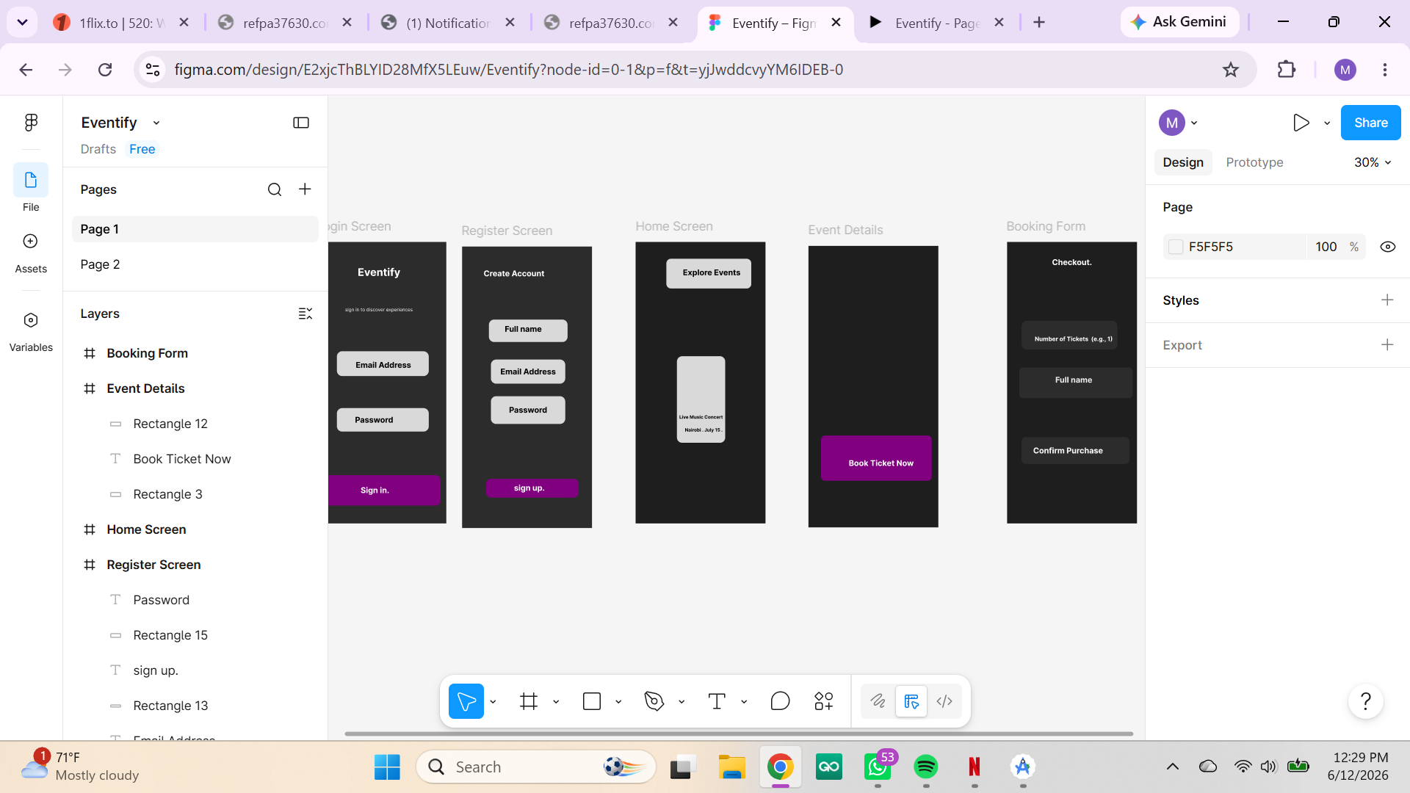
Fig 6: figma

Week 5: Data management and local storage
I created the SQLite database helper class to handle secure, local data storage operations.

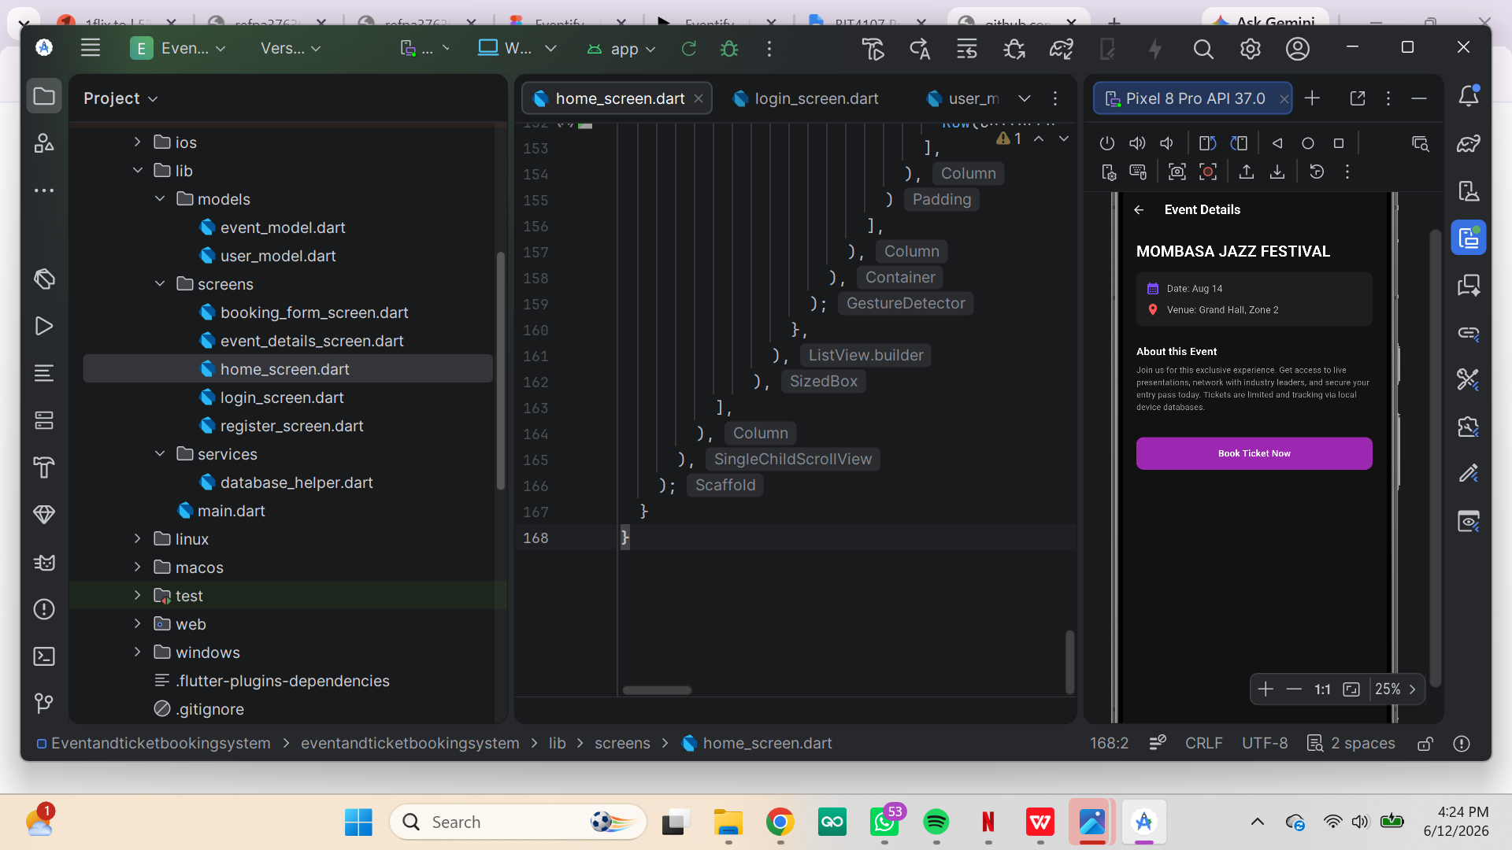

Fig 7:Data storage

Week 6; API and networking
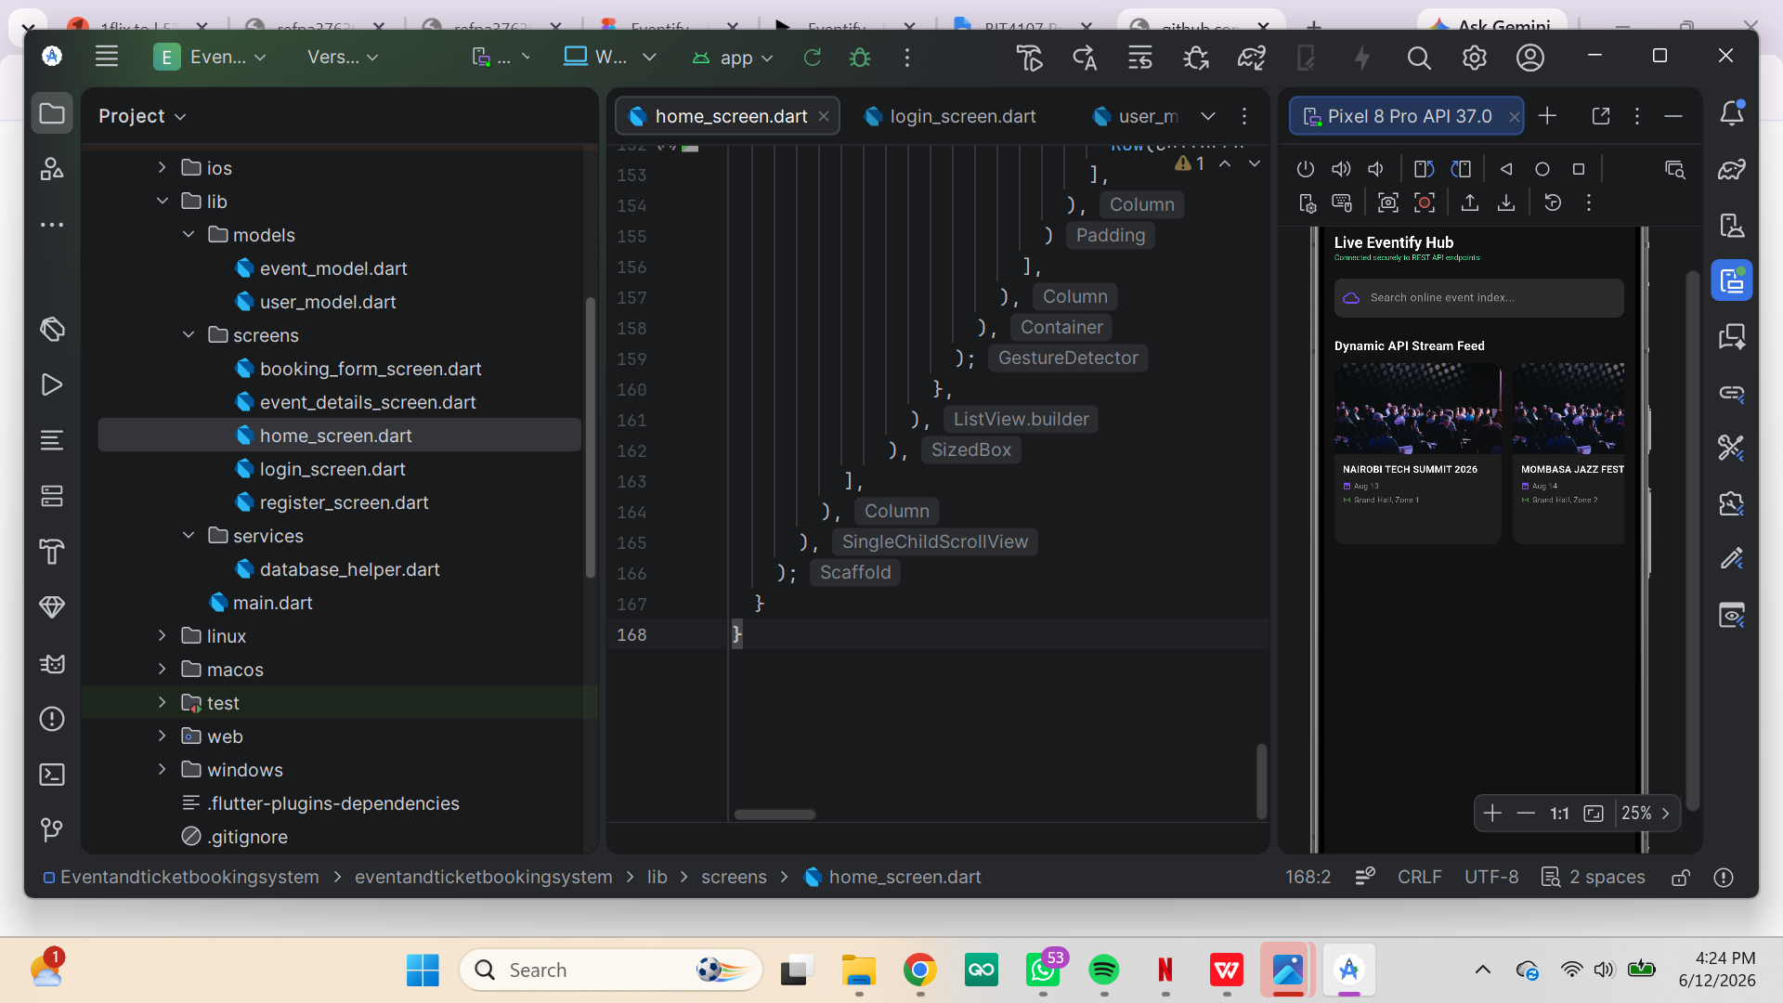
Fig 8: API integration

Week 7 : Application Architecture
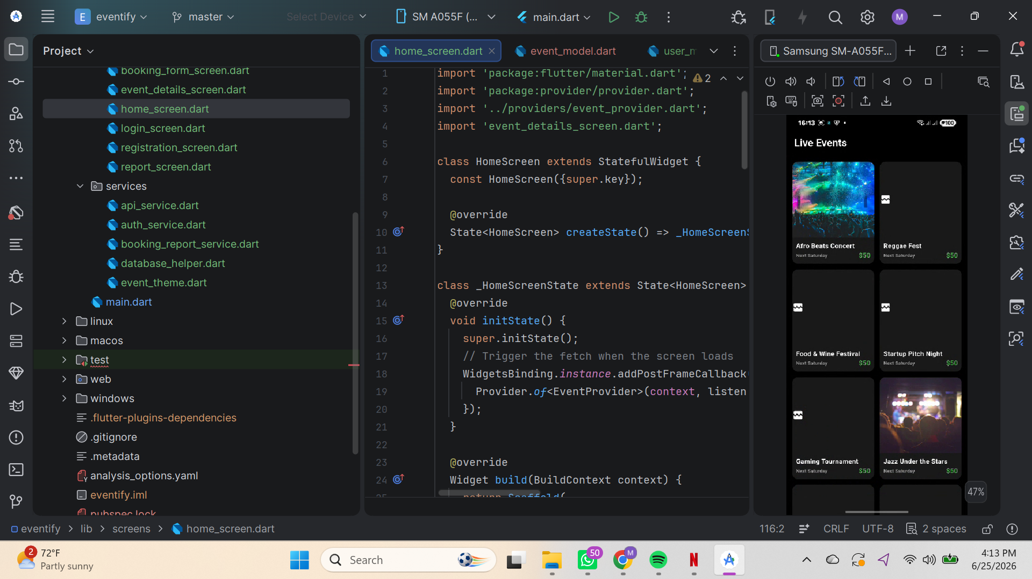
Fig 9: App architecture

